

Yedi Risdianto | 200511033 | TI20D

Tugas 3 : Membuat aplikasi konversi celcius, Fahrenheit dan reamur

1. **Konversi Celcius ke Fahrenheit**

Source Code :

Public Class CelciusToFahrenheit

Private Function convert(celcius As Integer) As Integer

Dim konversi As Integer

konversi = (9 / 5 * celcius) + 32

Return konversi

End Function

Private Sub btnConvert_Click(sender As Object, e As EventArgs) Handles btnConvert.Click

Dim celcius, fahrenheit As Integer

celcius = Val(txtCelcius.Text)

fahrenheit = convert(celcius)

txtFahrenheit.Text = Str(fahrenheit)

End Sub

End Class

Hasil Program Koversi Celcius ke Fahrenheit :

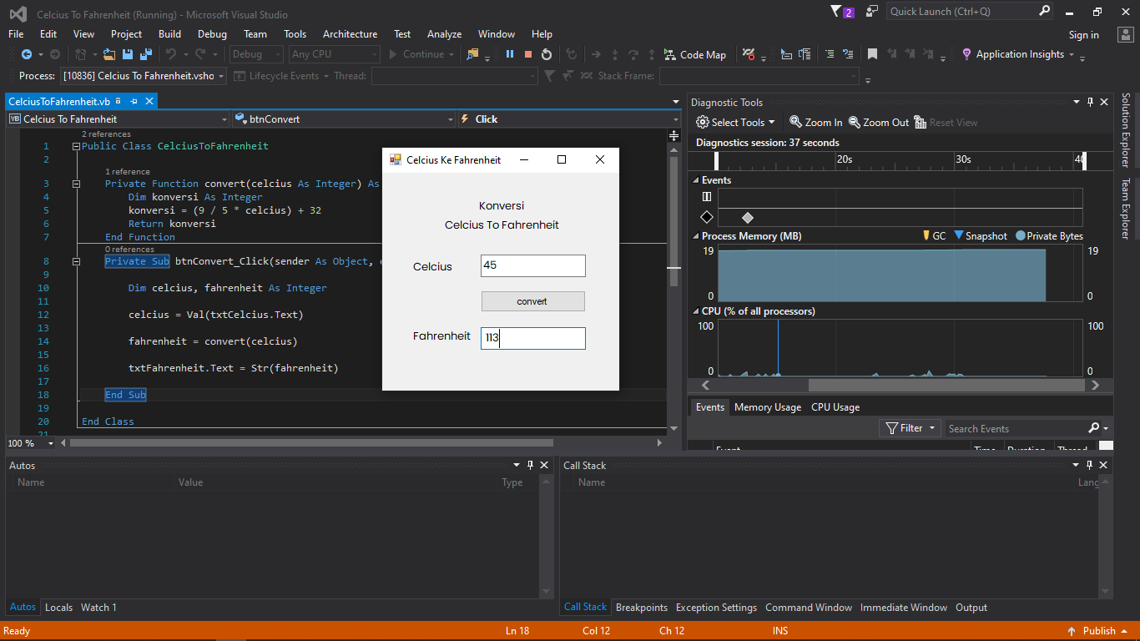

1. **Konversi Fahrenheit ke Reamur**

Source Code :

Public Class FahrenheitToReamur

Private Function convert(fahrenheit As Integer) As Integer

Dim konversi As Integer

konversi = 4 / 9 * (fahrenheit - 32)

Return konversi

End Function

Private Sub btnConvert_Click(sender As Object, e As EventArgs) Handles btnConvert.Click

Dim fahrenheit, reamur As Integer

fahrenheit = Val(txtFahrenheit.Text)

reamur = convert(fahrenheit)

txtReamur.Text = Str(reamur)

End Sub

End Class

Hasil Program Konversi Fahrenheit ke Reamur :

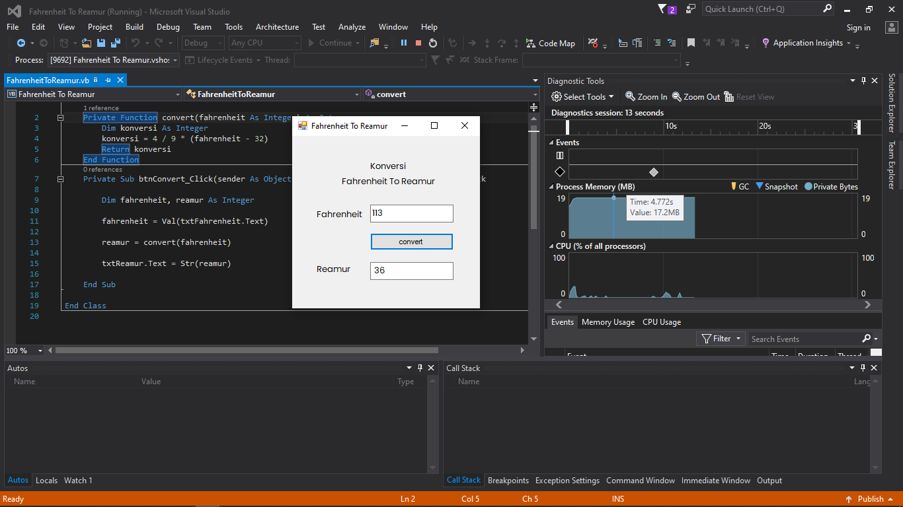

1. **Konversi Reamur ke Kelvin**

Source Code ;

Public Class ReamurToKelvin

Private Function convert(reamur As Integer) As Integer

Dim konversi As Integer

konversi = 5 / 4 * (reamur + 273)

Return konversi

End Function

Private Sub btnConvert_Click(sender As Object, e As EventArgs) Handles btnConvert.Click

Dim reamur, kelvin As Integer

reamur = Val(txtReamur.Text)

kelvin = convert(reamur)

txtKelvin.Text = Str(kelvin)

End Sub

End Class

Hasil Program Konversi Reamur ke Kelvin :

